1st District Communications Officers Report
Paul Ciarelli

I wanted to start off by saying that I’m only going to be as excited about this job as you are.
So far It hasn’t been very exciting.

I’m hoping that will change somewhat after this report.

Finances:

You may or may not know that Post 21 hosts 1dwilegion.org in their leased web space from a company called Hostwinds. Post 21 Pays about $450.00 for three years, everything included.
Besides the 1st District, we also host other sites like the Kenosha Area Vietnam Veterans web page, the Bunker Coffee House for Vets, the Heroes Café, and others. We have received donations for doing this amounting to about $300 in the first year. I think you could say that everybody wins in a scenario like that.

The cost to 1st District specifically for 1dwilegion.org is $23.48 annually for renewing that domain name. When we turn this over to the organization for collection, we ask for a donation, which, by the way, I am doing now.

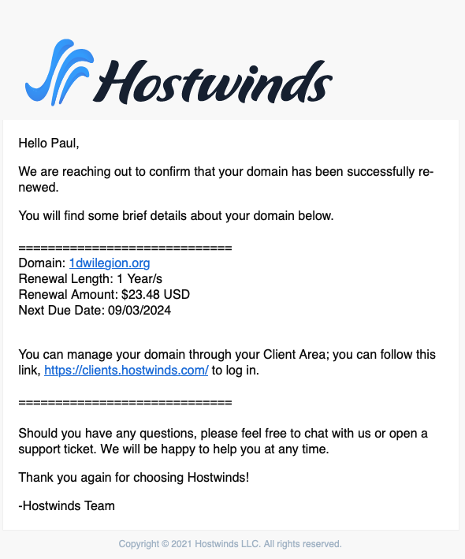

But why should the 1st District even pay that?

I hear the argument that websites aren’t necessary if we have Facebook.

First off, Facebook is for old people. Young people use it to keep in touch with their families, not generally their friends. They do not spend a lot of time of Facebook.

Secondly, the importance of websites is that they are a base of operations for your post.

Facebook was designed as a way to communicate, and it is good at that, but it is not good at static information.

For example, If I wanted to find pictures of an outing from two years ago on facebook, you have to scroll a lot or use searches that may or may not get you where you want to go. On a website, it’s usually right under a menu.

Some Important reasons to have a website:

- Supporting Veterans
  - Veteran Owned Business Listings
    - What better way to help younger veterans that have small business than to help them advertise.
    - For example, check out Post 21’s has their Red, White, and Blue Pages on https://alpost21.com
- Have a “Press Kit” online so local news and media have a place to go to get their information right in published works.
- Advertising

Take a look at 1dwilegion.org for yourself: https://1dwilegion.org

In any case, it’s up to you to use the 1st District’s IT resources.

Are there any questions or comments?

